- \Operation\Basic settings\Speed
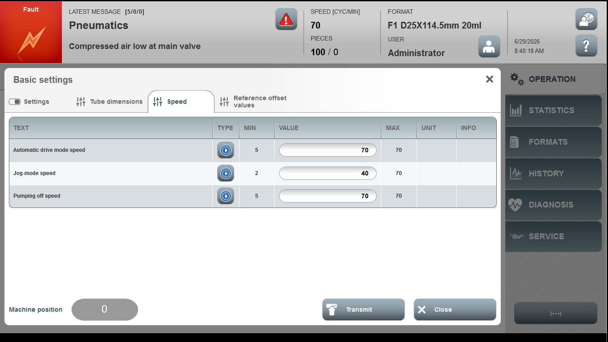
Acceptance criterion | Limits | Pass / Fail: Dev-No. | Date | Initials
Screen matches screenshot | N / A
Automatic speed | 5 … 70
Jog-mode speed | 2 … 70
Pumping off speed | 5 … 70

